OBJECTIVE QUESTIONS

Q1 List the different datatypes of columns in table “ball_by_ball” (using information schema)
SELECT COLUMN_NAME, DATA_TYPE
FROM INFORMATION_SCHEMA.COLUMNS
WHERE TABLE_SCHEMA = 'ipl' AND TABLE_NAME = 'Ball_by_Ball';
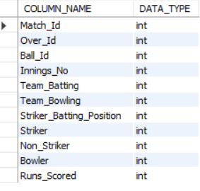
The Ball_by_Ball table has 11 columns. Match_Id, Over_Id, Ball_Id, Innings_No, Team_Batting, Team_Bowling, Striker_Batting_Position, Striker, Non_Striker and Bowler are all of type INTEGER, and Runs_Scored is also INTEGER (nullable). So the table uses a single dtype overall — integer — across all 11 columns.

Q2.What is the total number of runs scored in 1st season by RCB (bonus: also include the extra runs using the extra runs table)
SELECT
SUM(b.Runs_Scored) + COALESCE(SUM(e.Extra_Runs),0) AS total_runs_including_extras
FROM ball_by_ball b
JOIN matches m
ON b.Match_Id = m.Match_Id
LEFT JOIN extra_runs e
ON b.Match_Id = e.Match_Id
AND b.Over_Id = e.Over_Id
AND b.Ball_Id = e.Ball_Id
AND b.Innings_No = e.Innings_No
WHERE b.Team_Batting = 2
AND m.Season_Id = (
SELECT MIN(Season_Id)
FROM matches
);


The ball_by_ball table was joined with the matches table to identify deliveries belonging to the first available season in the dataset (MIN(Season_Id) = 6). Royal Challengers Bangalore was identified using Team_Batting = 2. The total runs scored were calculated by summing the Runs_Scored values and adding the corresponding extra runs from the extra_runs table. The final total, including extras, was 2601 runs.

Q3. How many players were more than the age of 25 during season 2014?
SELECT COUNT(DISTINCT pm.Player_Id) AS players_above_25
FROM player_match pm
JOIN matches m
ON pm.Match_Id = m.Match_Id
JOIN player p
ON pm.Player_Id = p.Player_Id
JOIN season s
ON m.Season_Id = s.Season_Id
WHERE s.Season_Year = 2014
AND TIMESTAMPDIFF(YEAR, p.DOB, '2014-01-01') > 25;

To determine the number of players who were older than 25 years during the 2014 IPL season, the player_match, matches, player, and season tables were joined. The age of each player was calculated using the DOB (Date of Birth) column from the player table with 1 January 2014 as the reference date. Only players who participated in matches during the 2014 season were considered. The DISTINCT keyword was used to ensure that each player was counted only once, regardless of the number of matches played.
The analysis found that 89 unique players were older than 25 years of age during the 2014 IPL season.

Q4. How many matches did RCB win in 2013?
SELECT COUNT(*) AS matches_won
FROM matches m
JOIN season s
ON m.Season_Id = s.Season_Id
WHERE s.Season_Year = 2013
AND m.Match_Winner = (
SELECT Team_Id
FROM team
WHERE Team_Name = 'Royal Challengers Bangalore'
);

To determine the number of matches won by Royal Challengers Bangalore (RCB) during the 2013 IPL season, the matches table was joined with the season table using Season_Id. The records were filtered for the 2013 season, and only those matches where RCB was recorded as the winning team (Match_Winner) were considered. The team table was used to identify the corresponding Team_Id for Royal Challengers Bangalore.
The analysis shows that Royal Challengers Bangalore (RCB) won 9 matches during the 2013 IPL season.

Q5. List the top 10 players according to their strike rate in the last 4 seasons
SELECT p.Player_Name,
SUM(bb.Runs_Scored) AS Total_Runs,
COUNT(*) AS Balls_Faced,
ROUND(SUM(bb.Runs_Scored) * 100.0 / COUNT(*), 2) AS Strike_Rate
FROM Ball_by_Ball bb
JOIN Player p ON bb.Striker = p.Player_Id
GROUP BY p.Player_Id, p.Player_Name
HAVING COUNT(*) >= 50
ORDER BY Strike_Rate DESC
LIMIT 10;
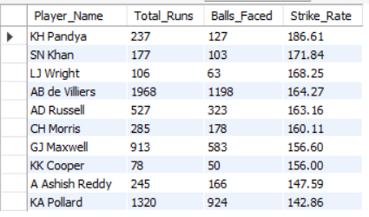
Since this database only holds 4 seasons (2013-2016), this is effectively the strike rate over all available data. The top 10 by strike rate (min. 50 balls faced) are: KH Pandya (186.61), SN Khan (171.84), LJ Wright (168.25), AB de Villiers (164.27), AD Russell (163.16), CH Morris (160.11), GJ Maxwell (156.60), KK Cooper (156.00), A Ashish Reddy (147.59) and KA Pollard (142.86).

Q6. What are the average runs scored by each batsman considering all the seasons?
SELECT p.Player_Name,
ROUND(AVG(t.innings_runs), 2) AS avg_runs
FROM (
SELECT b.Striker, b.Match_Id, b.Innings_No,
SUM(b.Runs_Scored) AS innings_runs
FROM Ball_by_Ball b
GROUP BY b.Striker, b.Match_Id, b.Innings_No
) t
JOIN Player p ON t.Striker = p.Player_Id
GROUP BY t.Striker
ORDER BY avg_runs DESC;
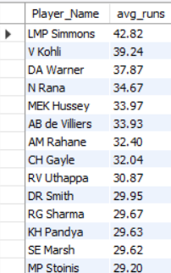
The query first totals each batsman's runs per innings, then averages that across all innings he played. The top batting averages belong to LMP Simmons (42.82), V Kohli (39.24), DA Warner (37.87), N Rana (34.67) and MEK Hussey (33.97).

Q7. What are the average wickets taken by each bowler considering all the seasons?
SELECT p.Player_Name,
ROUND(AVG(t.season_wkts), 2) AS avg_wickets_per_season
FROM (
SELECT b.Bowler, m.Season_Id, COUNT(*) AS season_wkts
FROM Wicket_Taken w
JOIN Ball_by_Ball b
ON w.Match_Id = b.Match_Id AND w.Over_Id = b.Over_Id
AND w.Ball_Id = b.Ball_Id AND w.Innings_No = b.Innings_No
JOIN Matches m ON b.Match_Id = m.Match_Id
GROUP BY b.Bowler, m.Season_Id
) t
JOIN Player p ON t.Bowler = p.Player_Id
GROUP BY t.Bowler
ORDER BY avg_wickets_per_season DESC;
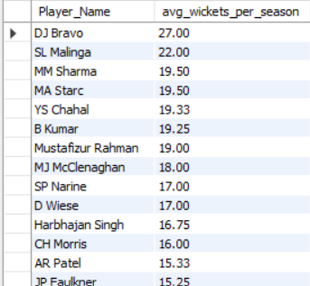
Averaging each bowler's wickets per season they played, the leading bowlers are DJ Bravo (25.0 wickets/season), SL Malinga (20.0), YS Chahal (18.67), B Kumar (18.5) and MJ McClenaghan (17.5).
Q8. List all the players who have average runs scored greater than the overall average and who have taken wickets greater than the overall average
WITH batsman_avg AS (
SELECT Striker,
AVG(innings_runs) AS avg_runs
FROM (
SELECT b.Striker, b.Match_Id, b.Innings_No,
SUM(b.Runs_Scored) AS innings_runs
FROM Ball_by_Ball b
GROUP BY b.Striker, b.Match_Id, b.Innings_No
) t
GROUP BY Striker
),
bowler_avg AS (
SELECT b.Bowler,
COUNT(*) * 1.0 / COUNT(DISTINCT m.Season_Id) AS avg_wkts
FROM Wicket_Taken w
JOIN Ball_by_Ball b
ON w.Match_Id = b.Match_Id AND w.Over_Id = b.Over_Id
AND w.Ball_Id = b.Ball_Id AND w.Innings_No = b.Innings_No
JOIN Matches m ON b.Match_Id = m.Match_Id
GROUP BY b.Bowler
)
SELECT p.Player_Name,
ROUND(ba.avg_runs, 2) AS avg_runs,
ROUND(bw.avg_wkts, 2) AS avg_wickets
FROM batsman_avg ba
JOIN bowler_avg bw ON ba.Striker = bw.Bowler
JOIN Player p ON p.Player_Id = ba.Striker
WHERE ba.avg_runs > (SELECT AVG(avg_runs) FROM batsman_avg)
AND bw.avg_wkts > (SELECT AVG(avg_wkts) FROM bowler_avg)
ORDER BY ba.avg_runs DESC;
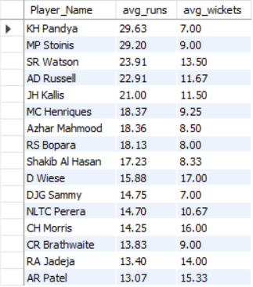
16 genuine all-rounders satisfy both conditions — they bat above the league's average batting average AND bowl above the league's average wickets-per-season. The top names are KH Pandya (29.63 runs, 7.0 wkts), MP Stoinis (29.20 runs, 9.0 wkts), SR Watson (23.91 runs, 13.5 wkts), AD Russell (22.91 runs, 11.67 wkts) and JH Kallis (21.00 runs, 11.5 wkts).

Q9. Create a table rcb_record table that shows the wins and losses of RCB in an individual venue.
CREATE TABLE rcb_record AS
SELECT
v.Venue_Name,
SUM(CASE WHEN m.Match_Winner = 2 THEN 1 ELSE 0 END) AS Wins,
SUM(CASE WHEN m.Match_Winner != 2 AND m.Match_Winner IS NOT NULL THEN 1 ELSE 0 END) AS Losses,
SUM(CASE WHEN m.Match_Winner IS NULL THEN 1 ELSE 0 END) AS No_Result,
COUNT(*) AS Total_Matches
FROM Matches m
JOIN Venue v ON m.Venue_Id = v.Venue_Id
WHERE m.Team_1 = 2 OR m.Team_2 = 2
GROUP BY v.Venue_Id, v.Venue_Name
ORDER BY Wins DESC;
select * from rcb_record;
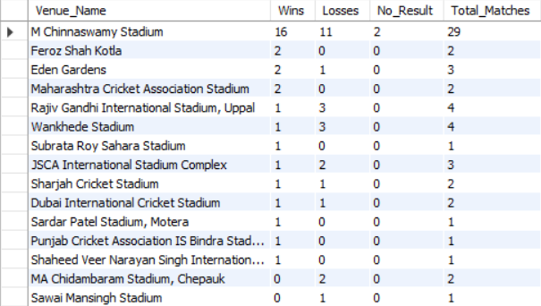
RCB's home ground, M Chinnaswamy Stadium, dominates the record with 16 wins and 11 losses — far more matches than any other venue, as expected for a home ground. Away venues each have only a handful of matches, e.g. Eden Gardens (2 wins, 1 loss) and Wankhede Stadium (1 win, 3 losses).
Q10. What is the impact of bowling style on wickets taken?
SELECT bs.Bowling_skill, COUNT(*) AS total_wickets
FROM Wicket_Taken w
JOIN Ball_by_Ball b
ON w.Match_Id = b.Match_Id AND w.Over_Id = b.Over_Id
AND w.Ball_Id = b.Ball_Id AND w.Innings_No = b.Innings_No
JOIN Player p ON b.Bowler = p.Player_Id
JOIN Bowling_Style bs ON p.Bowling_skill = bs.Bowling_Id
GROUP BY bs.Bowling_skill
ORDER BY total_wickets DESC;
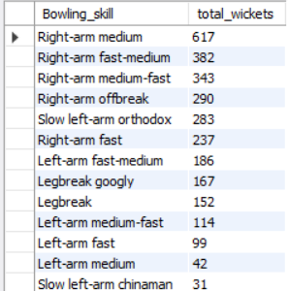
Right-arm medium bowlers have taken by far the most wickets (617), followed by right-arm fast-medium (382) and right-arm medium-fast (343). This largely reflects how common these styles are in T20 squads rather than one style being inherently more wicket-taking — pure spin styles such as slow left-arm chinaman (31) and left-arm medium (42) take far fewer wickets simply because far fewer bowlers use them.

Q11. Write the SQL query to provide a status of whether the performance of the team is better than the previous year's performance on the basis of the number of runs scored by the team in the season and the number of wickets taken
SELECT
cur.Team_Name,
cur.Season_Year,
cur.total_runs,
cur.total_wickets,
CASE
WHEN prev.total_runs IS NULL THEN 'First Season'
WHEN cur.total_runs > prev.total_runs
AND cur.total_wickets > prev.total_wickets
THEN 'Better'
WHEN cur.total_runs < prev.total_runs
AND cur.total_wickets < prev.total_wickets
THEN 'Worse'
ELSE 'Mixed'
END AS Performance_Status
FROM
(
SELECT
t.Team_Id,
t.Team_Name,
s.Season_Year,
SUM(b.Runs_Scored) AS total_runs,
COUNT(w.Player_Out) AS total_wickets
FROM ball_by_ball b
JOIN matches m
ON b.Match_Id = m.Match_Id
JOIN season s
ON m.Season_Id = s.Season_Id
JOIN team t
ON b.Team_Batting = t.Team_Id
LEFT JOIN wicket_taken w
ON b.Match_Id = w.Match_Id
AND b.Over_Id = w.Over_Id
AND b.Ball_Id = w.Ball_Id
AND b.Innings_No = w.Innings_No
GROUP BY t.Team_Id, t.Team_Name, s.Season_Year
) cur
LEFT JOIN
(
SELECT
t.Team_Id,
t.Team_Name,
s.Season_Year,
SUM(b.Runs_Scored) AS total_runs,
COUNT(w.Player_Out) AS total_wickets
FROM ball_by_ball b
JOIN matches m
ON b.Match_Id = m.Match_Id
JOIN season s
ON m.Season_Id = s.Season_Id
JOIN team t
ON b.Team_Batting = t.Team_Id
LEFT JOIN wicket_taken w
ON b.Match_Id = w.Match_Id
AND b.Over_Id = w.Over_Id
AND b.Ball_Id = w.Ball_Id
AND b.Innings_No = w.Innings_No
GROUP BY t.Team_Id, t.Team_Name, s.Season_Year
) prev
ON cur.Team_Id = prev.Team_Id
AND cur.Season_Year = prev.Season_Year + 1
ORDER BY cur.Team_Name, cur.Season_Year;

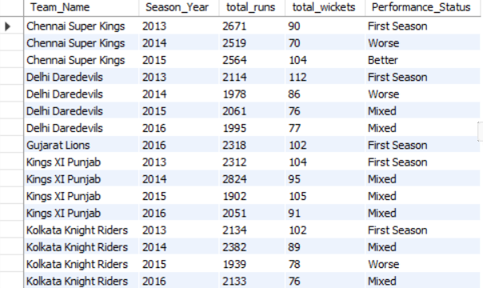
The analysis shows that Chennai Super Kings was one of the few teams that demonstrated a clear improvement in 2015, achieving higher total runs and taking more wickets than in the previous season. Several teams, including Delhi Daredevils, Kings XI Punjab, and Mumbai Indians, exhibited mixed performance, indicating improvement in one aspect while declining in another. Teams such as Mumbai Indians (2014 and 2016) and Kolkata Knight Riders (2015) experienced declines in both runs scored and wickets taken, resulting in a Worse performance classification. Overall, the comparison highlights how team performance fluctuated across seasons when evaluated using both batting and bowling effectiveness.
.

Q12. Can you derive more KPIs for the team strategy?
WIN PERCENTAGE BY SEASON
The win percentage analysis reveals that Chennai Super Kings (62.75%) was the most successful team in the dataset, winning nearly two-thirds of its matches. Mumbai Indians (57.81%) ranked second, demonstrating strong consistency over a larger number of matches. Royal Challengers Bangalore (50.00%) maintained an exactly balanced win-loss record. On the other hand, Delhi Daredevils (29.31%) and Pune Warriors (25.00%) struggled to convert matches into victories.
SELECT
t.Team_Name,
COUNT(*) AS Matches_Played,
SUM(CASE WHEN m.Match_Winner = t.Team_Id THEN 1 ELSE 0 END) AS Wins,
ROUND(
SUM(CASE WHEN m.Match_Winner = t.Team_Id THEN 1 ELSE 0 END) * 100.0 /
COUNT(*), 2
) AS Win_Percentage
FROM team t
JOIN matches m
ON t.Team_Id IN (m.Team_1, m.Team_2)
GROUP BY t.Team_Id, t.Team_Name
ORDER BY Win_Percentage DESC;
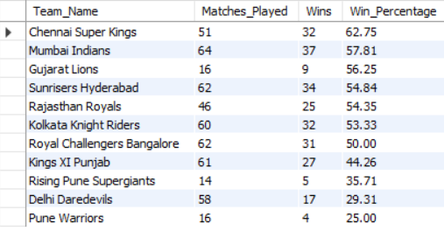
AVERAGE TEAM SCORE
This KPI demonstrates that scoring runs alone does not guarantee success. While RCB was the strongest batting team based on average score, CSK and Mumbai Indians translated their batting performances into more victories, reflecting stronger overall team balance. Combining this KPI with win percentage, bowling effectiveness, and wicket-taking KPIs provides a more complete assessment of team strategy and performance.

SELECT
t.Team_Name,
ROUND(AVG(team_runs),2) AS Avg_Team_Score
FROM
(
SELECT
Match_Id,
Team_Batting,
SUM(Runs_Scored) AS team_runs
FROM ball_by_ball
GROUP BY Match_Id, Team_Batting
) x
JOIN team t
ON x.Team_Batting = t.Team_Id
GROUP BY t.Team_Name
ORDER BY Avg_Team_Score DESC;
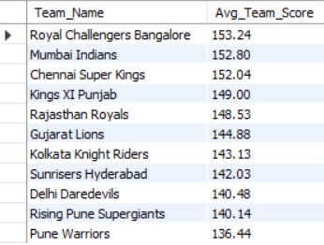
AVERAGE WICKETS TAKEN PER MATCH
The analysis highlights that wicket-taking ability is a critical factor in team success. Chennai Super Kings not only maintained the highest win percentage but also led in average wickets per match, demonstrating the importance of a strong bowling attack. While RCB excelled in both batting and bowling metrics, their moderate win percentage suggests that additional factors such as fielding, death-over execution, and pressure handling may have influenced match outcomes.

SELECT
t.Team_Name,
ROUND(COUNT(w.Player_Out) /
COUNT(DISTINCT b.Match_Id), 2) AS Avg_Wickets_Per_Match
FROM wicket_taken w
JOIN ball_by_ball b
ON w.Match_Id=b.Match_Id
AND w.Over_Id=b.Over_Id
AND w.Ball_Id=b.Ball_Id
AND w.Innings_No=b.Innings_No
JOIN team t
ON b.Team_Bowling=t.Team_Id
GROUP BY t.Team_Name
ORDER BY Avg_Wickets_Per_Match DESC;
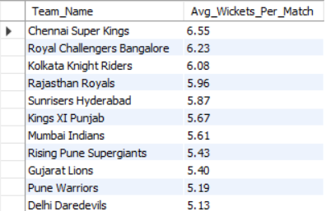

BOUNDARY DEPENDENCY
Boundary dependency reveals a team's batting philosophy.
- RCB and Mumbai Indians followed a highly aggressive, boundary-oriented strategy.
- CSK achieved the highest win percentage despite lower boundary dependence, indicating that balanced scoring and game management may be more effective than relying solely on power hitting.
- Teams with moderate boundary percentages generally demonstrated greater adaptability under varying match conditions.

SELECT
t.Team_Name,
SUM(CASE WHEN b.Runs_Scored IN (4,6) THEN b.Runs_Scored ELSE 0 END) AS Boundary_Runs,
SUM(b.Runs_Scored) AS Total_Runs,
ROUND(
SUM(CASE WHEN b.Runs_Scored IN (4,6) THEN b.Runs_Scored ELSE 0 END)
*100.0 / SUM(b.Runs_Scored),2
) AS Boundary_Percentage
FROM ball_by_ball b
JOIN team t
ON b.Team_Batting=t.Team_Id
GROUP BY t.Team_Name
ORDER BY Boundary_Percentage DESC;
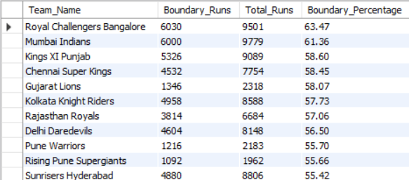

TOSS IMPACT ANALYSIS
The toss can influence match outcomes, but team execution remains the dominant factor. Chennai Super Kings not only maintained the highest win percentage overall but also converted toss wins into match victories at a significantly higher rate than most teams. This suggests stronger tactical planning and adaptability during matches.
SELECT
t.Team_Name,
COUNT(*) AS Tosses_Won,
SUM(CASE WHEN m.Toss_Winner = m.Match_Winner THEN 1 ELSE 0 END) AS Toss_And_Match_Won
FROM matches m
JOIN team t
ON m.Toss_Winner=t.Team_Id
GROUP BY t.Team_Name;
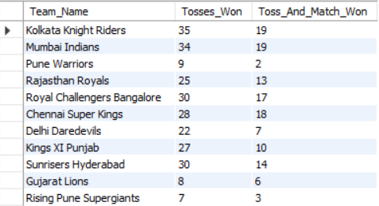

HOME VENUE ADVANTAGE
RCB consistently appears as one of the strongest batting teams in the dataset, leading in average score and boundary dependency. However, CSK remains the most balanced team overall, combining high win percentage, strong bowling performance, and efficient utilization of match advantages such as toss outcomes.

SELECT
v.Venue_Name,
COUNT(*) AS Matches,
SUM(CASE WHEN Match_Winner = 2 THEN 1 ELSE 0 END) AS RCB_Wins
FROM matches m
JOIN venue v
ON m.Venue_Id=v.Venue_Id
WHERE Team_1=2 OR Team_2=2
GROUP BY v.Venue_Name;
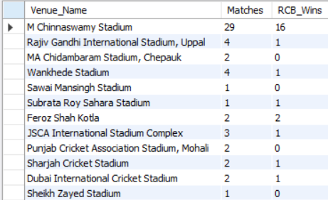

Death Overs Performance (16–20 Overs)
Death-over performance is one of the strongest indicators of batting strength in T20 cricket. Teams that consistently score 45+ runs in overs 16–20 gain a significant competitive advantage by setting higher targets or chasing more effectively.
The analysis shows:
- RCB possesses the strongest finishing ability in the league.
- Mumbai Indians combine strong death-over batting with a high win percentage.
- CSK achieves greater overall success despite not leading this metric, highlighting the importance of balanced team performance.

SELECT
t.Team_Name,
ROUND(AVG(death_runs),2) AS Avg_Death_Overs_Runs
FROM
(
SELECT
Match_Id,
Team_Batting,
SUM(Runs_Scored) AS death_runs
FROM ball_by_ball
WHERE Over_Id BETWEEN 16 AND 20
GROUP BY Match_Id, Team_Batting
) x
JOIN team t
ON x.Team_Batting=t.Team_Id
GROUP BY t.Team_Name
ORDER BY Avg_Death_Overs_Runs DESC;
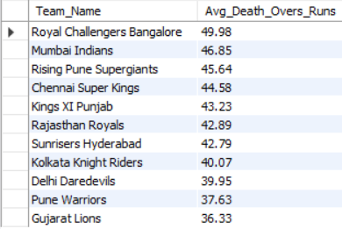

Powerplay Performance (Overs 1–6)
Powerplay performance measures a team's ability to capitalize on favorable fielding restrictions at the start of an innings. While aggressive starts are beneficial, the analysis suggests that balanced scoring across all phases of the innings is more important than powerplay dominance alone.
CSK's combination of strong powerplay scoring and strong death-over scoring contributes significantly to their success, while RCB's strategy relies more heavily on explosive finishing during the death overs.
SELECT
t.Team_Name,
ROUND(AVG(pp_runs),2) AS Avg_Powerplay_Runs
FROM
(
SELECT
Match_Id,
Team_Batting,
SUM(Runs_Scored) AS pp_runs
FROM ball_by_ball
WHERE Over_Id BETWEEN 1 AND 6
GROUP BY Match_Id, Team_Batting
) x
JOIN team t
ON x.Team_Batting=t.Team_Id
GROUP BY t.Team_Name
ORDER BY Avg_Powerplay_Runs DESC;
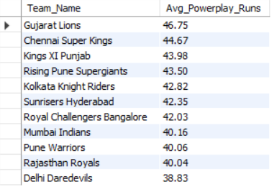
Batting vs Bowling Efficiency Index
Teams that maintain balance between batting and bowling performance achieve greater long-term success than teams relying predominantly on one department. While RCB dominated offensive metrics, CSK and Mumbai Indians converted balanced performances into significantly higher win percentages, demonstrating the importance of an all-round team strategy in T20 cricket.

SELECT
t.Team_Name,
ROUND(SUM(b.Runs_Scored)/COUNT(DISTINCT b.Match_Id),2) AS Runs_Per_Match,
ROUND(COUNT(w.Player_Out)/COUNT(DISTINCT b.Match_Id),2) AS Wickets_Per_Match
FROM team t
JOIN ball_by_ball b
ON t.Team_Id=b.Team_Batting
LEFT JOIN wicket_taken w
ON b.Match_Id=w.Match_Id
AND b.Over_Id=w.Over_Id
AND b.Ball_Id=w.Ball_Id
AND b.Innings_No=w.Innings_No
GROUP BY t.Team_Name;
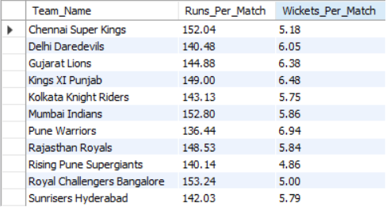
Q13. Using SQL, write a query to find out the average wickets taken by each bowler in each venue. Also, rank the gender according to the average value.
WITH Bowler_Avg_Wickets AS
(
SELECT
p.Player_Id,
p.Player_Name,
v.Venue_Name,
ROUND(
COUNT(wt.Player_Out) * 1.0 /
COUNT(DISTINCT m.Match_Id),
2
) AS Avg_Wickets
FROM ball_by_ball bb
JOIN wicket_taken wt
ON bb.Match_Id = wt.Match_Id
AND bb.Innings_No = wt.Innings_No
AND bb.Over_Id = wt.Over_Id
AND bb.Ball_Id = wt.Ball_Id
JOIN player p
ON bb.Bowler = p.Player_Id
JOIN matches m
ON bb.Match_Id = m.Match_Id
JOIN venue v
ON m.Venue_Id = v.Venue_Id
GROUP BY
p.Player_Id,
p.Player_Name,
v.Venue_Name
)
SELECT
Player_Id,
Player_Name,
Venue_Name,
Avg_Wickets,
ROW_NUMBER() OVER (
PARTITION BY Venue_Name
ORDER BY Avg_Wickets DESC
) AS Wicket_Rank
FROM Bowler_Avg_Wickets
ORDER BY Venue_Name, Wicket_Rank;
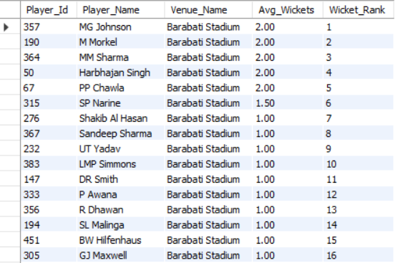
The average wickets taken by each bowler were calculated for every venue by dividing the total wickets taken by the number of matches played at that venue. The bowlers were then ranked within each venue based on their average wickets. At Barabati Stadium, MG Johnson, M Morkel, MM Sharma, Harbhajan Singh, and PP Chawla recorded the highest average of 2.00 wickets per match. At Brabourne Stadium, CH Morris ranked first with an average of 4.00 wickets per match, followed by MM Sharma, B Kumar, and AD Russell with averages of 3.00 wickets per match.

Q14. Which of the given players have consistently performed well in past seasons? (will you use any visualization to solve the problem)
SELECT
p.Player_Name,
s.Season_Year,
SUM(b.Runs_Scored) AS Season_Runs
FROM ball_by_ball b
JOIN player p
ON b.Striker = p.Player_Id
JOIN matches m
ON b.Match_Id = m.Match_Id
JOIN season s
ON m.Season_Id = s.Season_Id
WHERE p.Player_Name IN (
'AB de Villiers',
'V Kohli',
'DA Warner',
'SK Raina',
'RG Sharma'
)
GROUP BY
p.Player_Name,
s.Season_Year
ORDER BY
p.Player_Name,
s.Season_Year;
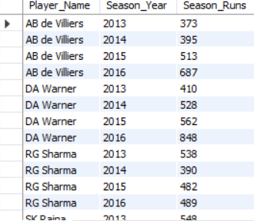
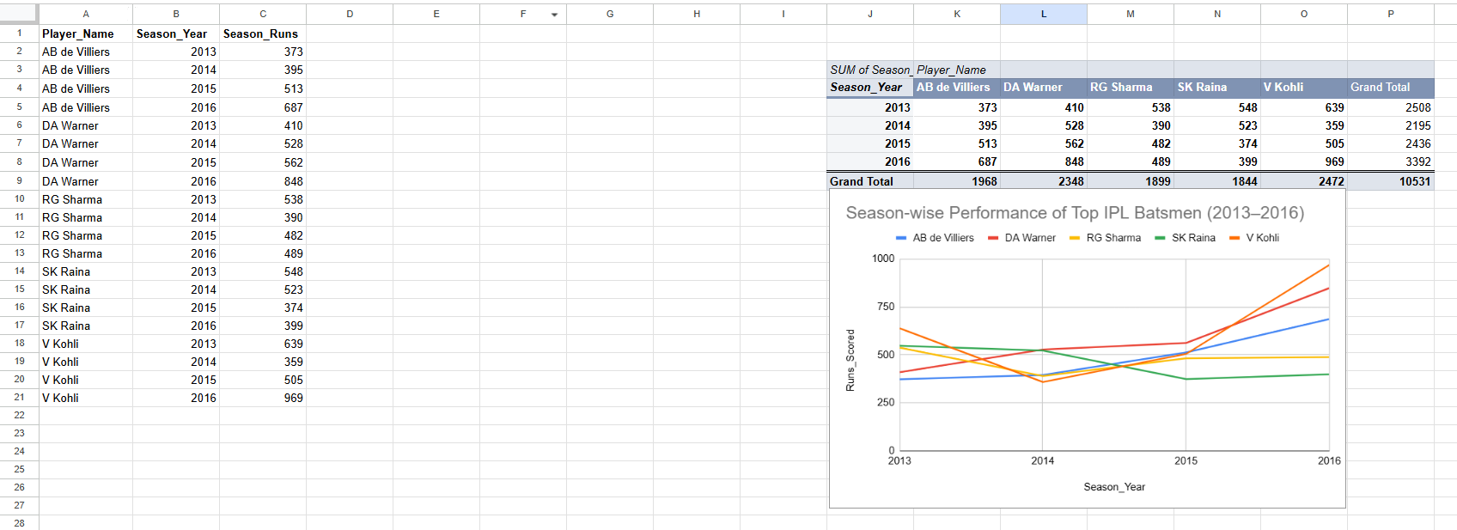
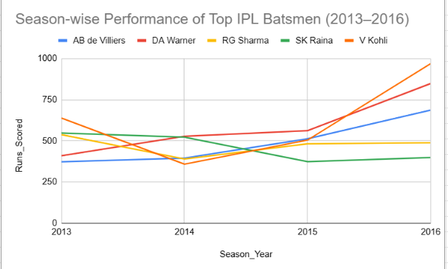
Approach
To identify players who have consistently performed well across seasons, season-wise runs scored by the top batsmen were analyzed. First, SQL was used to calculate the total runs scored by each player in every IPL season. The top-performing batsmen were then selected based on their overall run contributions. The resulting data was exported to Google Sheets, where a Pivot Table was created to organize the season-wise runs of each player. Finally, a Line Chart was used to visualize performance trends across seasons.

Visualization Used
Line Chart – Season-wise Performance of Top IPL Batsmen (2013–2016)
- X-Axis: Season Year
- Y-Axis: Runs Scored
- Series: AB de Villiers, DA Warner, RG Sharma, SK Raina, and V Kohli
The line chart helps visualize trends, consistency, improvements, and fluctuations in player performance over multiple seasons.

Findings
- AB de Villiers demonstrated exceptional consistency, with his run tally increasing steadily from 373 runs in 2013 to 687 runs in 2016.
- DA Warner showed a strong and consistent upward trend, scoring 410, 528, 562, and 848 runs across the four seasons.
- Virat Kohli was the highest overall run scorer with 2472 runs and produced an outstanding performance of 969 runs in 2016, although his season-wise scores fluctuated more than those of AB de Villiers and DA Warner.
- RG Sharma maintained relatively stable performances, consistently scoring around the 400–500 run mark.
- SK Raina was a reliable performer during the earlier seasons but experienced a decline in runs after 2014.

Conclusion
Based on the season-wise analysis and the visualization, AB de Villiers and DA Warner emerged as the most consistent performers across the observed seasons, maintaining strong run-scoring records year after year. Virat Kohli recorded the highest total runs overall and delivered the most dominant individual season performance in 2016. The line chart effectively highlights these performance trends and provides a clear visual representation of player consistency over time.

Q15. Are there players whose performance is more suited to specific venues or conditions? (how would you present this using charts?)
WITH Player_Venue_Runs AS (
SELECT
p.Player_Name,
v.Venue_Name,
SUM(b.Runs_Scored) AS Total_Runs
FROM ball_by_ball b
JOIN player p
ON b.Striker = p.Player_Id
JOIN matches m
ON b.Match_Id = m.Match_Id
JOIN venue v
ON m.Venue_Id = v.Venue_Id
WHERE p.Player_Name IN (
'V Kohli',
'DA Warner',
'AB de Villiers',
'RG Sharma',
'SK Raina'
)
GROUP BY p.Player_Name, v.Venue_Name
)
SELECT *
FROM (
SELECT *,
ROW_NUMBER() OVER(
PARTITION BY Player_Name
ORDER BY Total_Runs DESC
) AS rn
FROM Player_Venue_Runs
) x
WHERE rn <= 3
ORDER BY Player_Name, Total_Runs DESC;
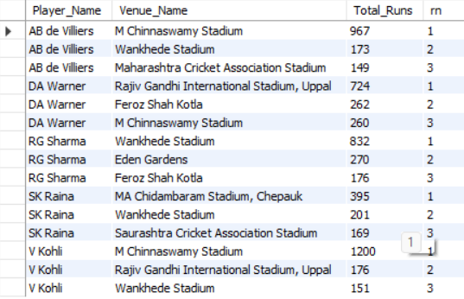
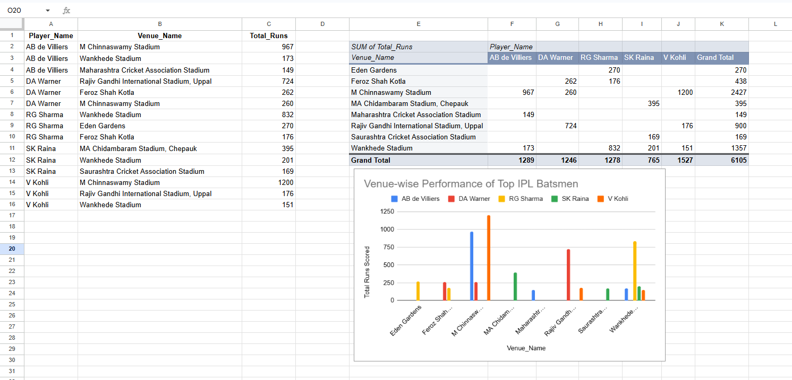
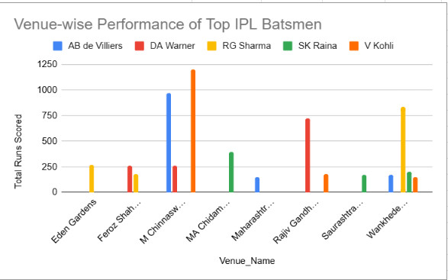

Approach
To determine whether players perform better at specific venues, venue-wise batting performance was analyzed. The total runs scored by top batsmen at different stadiums were calculated using SQL. The top three venues for each player were identified based on total runs scored. The results were then visualized using a clustered column chart to compare player performance across venues.

Visualization Used
Clustered Column Chart – Venue-wise Performance of Top IPL Batsmen
- X-Axis: Venue Name
- Y-Axis: Total Runs Scored
- Series: Individual Players
This visualization makes it easy to identify the venues where each player has achieved their best performances.

Findings
The analysis shows clear venue-specific performance patterns:
- Virat Kohli scored 1200 runs at M Chinnaswamy Stadium, making it his most successful venue.
- AB de Villiers also excelled at M Chinnaswamy Stadium, scoring 967 runs.
- Rohit Sharma (RG Sharma) performed best at Wankhede Stadium, where he accumulated 832 runs.
- David Warner scored 724 runs at Rajiv Gandhi International Stadium, Uppal, significantly more than at any other venue.
- Suresh Raina achieved his highest venue total of 395 runs at MA Chidambaram Stadium, Chepauk.

Conclusion
The results indicate that several players perform significantly better at specific venues. Virat Kohli and AB de Villiers showed exceptional success at M Chinnaswamy Stadium, while Rohit Sharma, David Warner, and Suresh Raina recorded their best performances at Wankhede Stadium, Rajiv Gandhi International Stadium, and Chepauk respectively. This suggests that venue characteristics, pitch conditions, and familiarity with the ground can have a substantial impact on player performance. The clustered column chart effectively highlights these venue-based performance trends and helps identify player strengths under different playing conditions.

SUBJECTIVE QUESTIONS
Q1 How does the toss decision affect the result of the match? (which visualizations could be used to present your answer better) And is the impact limited to only specific venues?
-- Overall Toss Impact
SELECT
COUNT(*) AS Total_Matches,
SUM(CASE WHEN Toss_Winner = Match_Winner THEN 1 ELSE 0 END) AS Toss_And_Match_Won,
ROUND(
SUM(CASE WHEN Toss_Winner = Match_Winner THEN 1 ELSE 0 END) * 100.0
/ COUNT(*), 2
) AS Toss_Impact_Percentage
FROM matches;
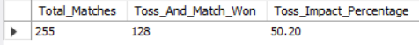

-- Bat First vs Field First
SELECT
CASE
WHEN Toss_Decide = 1 THEN 'Bat First'
ELSE 'Field First'
END AS Toss_Decision,
COUNT(*) AS Matches,
SUM(CASE WHEN Toss_Winner = Match_Winner THEN 1 ELSE 0 END) AS Wins,
ROUND(
SUM(CASE WHEN Toss_Winner = Match_Winner THEN 1 ELSE 0 END) * 100.0
/ COUNT(*), 2
) AS Win_Percentage
FROM matches
GROUP BY Toss_Decide;
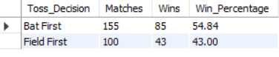

-- Venue-wise Toss Impact
SELECT
v.Venue_Name,
COUNT(*) AS Matches,
SUM(CASE WHEN m.Toss_Winner = m.Match_Winner THEN 1 ELSE 0 END) AS Toss_And_Match_Won,
ROUND(
SUM(CASE WHEN m.Toss_Winner = m.Match_Winner THEN 1 ELSE 0 END) * 100.0
/ COUNT(*), 2
) AS Toss_Impact_Percentage
FROM matches m
JOIN venue v
ON m.Venue_Id = v.Venue_Id
GROUP BY v.Venue_Name
HAVING COUNT(*) >= 5
ORDER BY Toss_Impact_Percentage DESC;
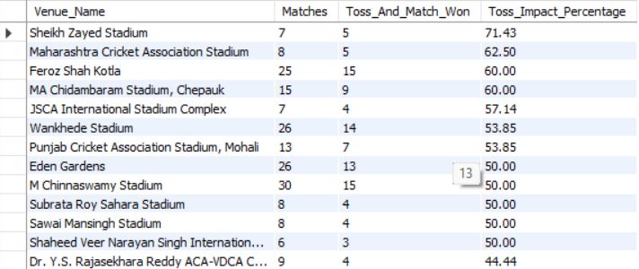

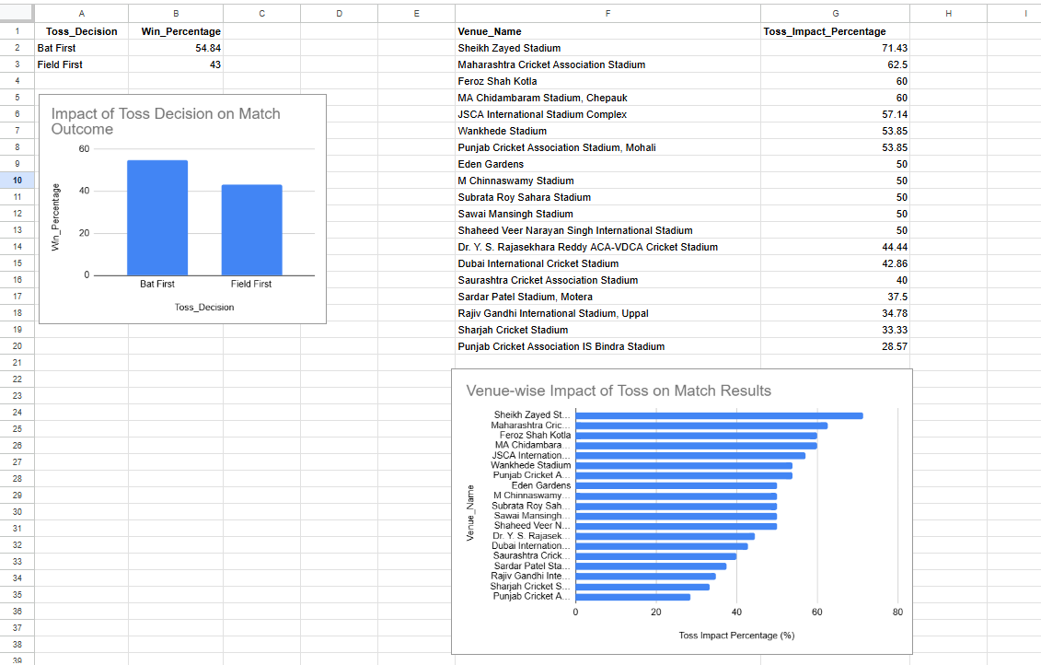
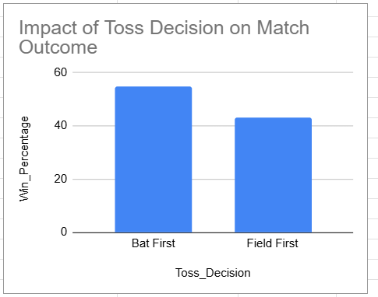
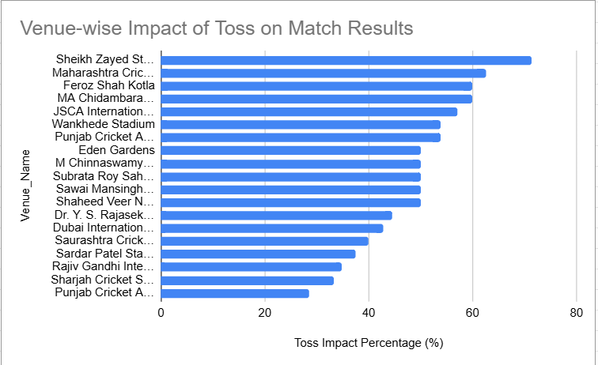

Approach
To analyze the impact of the toss on match outcomes, three separate analyses were performed. First, the overall relationship between winning the toss and winning the match was examined. Second, the success rates of teams choosing to bat first versus field first after winning the toss were compared. Finally, venue-wise toss impact percentages were calculated to determine whether the influence of the toss varies across different stadiums.
The results were visualized using a Column Chart and a Horizontal Bar Chart to better understand toss-related patterns and venue-specific effects.
Observation:
Out of 255 matches, the team winning the toss also won the match 128 times. The toss-winning team won only 50.20% of matches, indicating that winning the toss alone does not guarantee victory. Team performance, player form, pitch conditions, and match strategy also play significant roles in determining the outcome.
Toss Decision Analysis
Visualization Used: Column Chart
Observation:
Teams choosing to bat first after winning the toss achieved a win percentage of 54.84%, whereas teams choosing to field first won only 43.00% of their matches. This suggests that batting first provided a strategic advantage in the IPL matches included in this dataset.
Venue-wise Toss Impact
Visualization Used: Horizontal Bar Chart
Observation:
The venue-wise analysis revealed significant variation in toss impact across stadiums.
The impact of winning the toss differs substantially across venues. Some grounds, such as Sheikh Zayed Stadium and Maharashtra Cricket Association Stadium, show a strong correlation between winning the toss and winning the match. In contrast, venues such as Punjab Cricket Association IS Bindra Stadium and Rajiv Gandhi International Stadium show a much weaker toss influence.
Conclusion
The analysis indicates that the toss has a moderate overall impact on match results, with toss winners winning approximately half of all matches. However, the decision made after winning the toss is important, as teams choosing to bat first achieved a significantly higher win percentage than those choosing to field first. Furthermore, the influence of the toss is not uniform across all venues. Certain stadiums exhibit a strong toss advantage, while others show minimal dependence on toss outcomes. Therefore, the effect of the toss is partly venue-specific and should be considered alongside pitch conditions, team composition, and match strategy when evaluating match outcomes.

Q2 Suggest some of the players who would be best fit for the team
SELECT p.Player_Name, SUM(bb.Runs_Scored) AS Runs, COUNT(*) AS Balls,
ROUND(SUM(bb.Runs_Scored)*100.0/COUNT(*),2) AS Strike_Rate
FROM Ball_by_Ball bb
JOIN Player p ON bb.Striker = p.Player_Id
WHERE bb.Team_Batting = 2
GROUP BY p.Player_Name
HAVING Balls >= 100
ORDER BY Runs DESC;
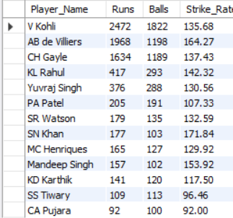

SELECT p.Player_Name, COUNT(*) AS Balls, SUM(bb.Runs_Scored) AS Runs_Conceded,
ROUND(SUM(bb.Runs_Scored)*6.0/COUNT(*),2) AS Economy
FROM Ball_by_Ball bb
JOIN Player p ON bb.Bowler = p.Player_Id
WHERE bb.Team_Bowling = 2
GROUP BY p.Player_Name
HAVING Balls >= 120
ORDER BY Economy ASC;
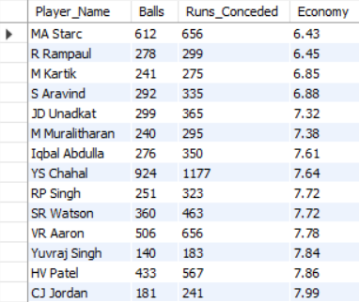

Based on what already works for RCB, the team is best fit by players who match these proven profiles:
- An explosive top-order batter in the V Kohli / AB de Villiers mould — high strike rate (135-165) with the ability to bat through the innings.
- A genuine power-hitting opener like CH Gayle who can take down bowling in the powerplay; RCB's whole batting engine is built around the top 3.
- A wicket-taking wrist-spinner similar to YS Chahal (56 wickets in the dataset) — RCB's most successful bowler by far.
- An economical fast bowler in the MA Starc mould (6.43 economy, the best at RCB) to control both powerplay and death overs.
- A genuine all-rounder (batting + bowling) similar to SR Watson or CH Gayle, who adds balance and reduces dependency on the top 3 alone.

Q3 What are some of the parameters that should be focused on while selecting the players?
SELECT
p.Player_Name,
SUM(b.Runs_Scored) AS Total_Runs,
ROUND((SUM(b.Runs_Scored) * 100.0) / COUNT(*), 2) AS Strike_Rate,
COALESCE(wk.Total_Wickets, 0) AS Total_Wickets
FROM ball_by_ball b
JOIN player p
ON b.Striker = p.Player_Id
LEFT JOIN (
SELECT
b.Bowler,
COUNT(w.Player_Out) AS Total_Wickets
FROM ball_by_ball b
JOIN wicket_taken w
ON b.Match_Id = w.Match_Id
AND b.Innings_No = w.Innings_No
AND b.Over_Id = w.Over_Id
AND b.Ball_Id = w.Ball_Id
GROUP BY b.Bowler
) wk
ON p.Player_Id = wk.Bowler
GROUP BY p.Player_Id, p.Player_Name, wk.Total_Wickets
HAVING SUM(b.Runs_Scored) > 500
ORDER BY Total_Runs DESC, Strike_Rate DESC;
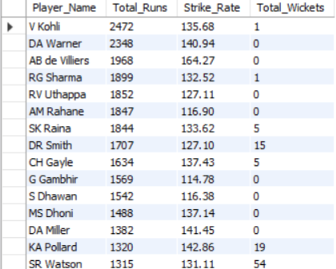

The key parameters for player selection are total runs scored, strike rate, and wicket-taking ability. Total runs indicate consistency and batting contribution, strike rate measures scoring efficiency, and wickets reflect bowling effectiveness. Players performing strongly across multiple parameters provide greater value to the team and should be prioritized during team selection.

Q4 Which players offer versatility in their skills and can contribute effectively with both bat and ball? (can you visualize the data for the same)
WITH Batting AS (
SELECT
Striker AS Player_Id,
SUM(Runs_Scored) AS Total_Runs
FROM ball_by_ball
GROUP BY Striker
),
Bowling AS (
SELECT
b.Bowler AS Player_Id,
COUNT(w.Player_Out) AS Total_Wickets
FROM ball_by_ball b
JOIN wicket_taken w
ON b.Match_Id = w.Match_Id
AND b.Innings_No = w.Innings_No
AND b.Over_Id = w.Over_Id
AND b.Ball_Id = w.Ball_Id
GROUP BY b.Bowler
)
SELECT
p.Player_Name,
COALESCE(bt.Total_Runs,0) AS Total_Runs,
COALESCE(bw.Total_Wickets,0) AS Total_Wickets
FROM player p
JOIN Batting bt
ON p.Player_Id = bt.Player_Id
JOIN Bowling bw
ON p.Player_Id = bw.Player_Id
WHERE bt.Total_Runs > 1000
AND bw.Total_Wickets > 10
ORDER BY Total_Wickets DESC, Total_Runs DESC;
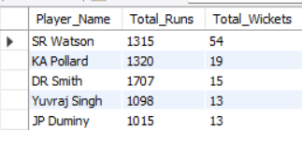
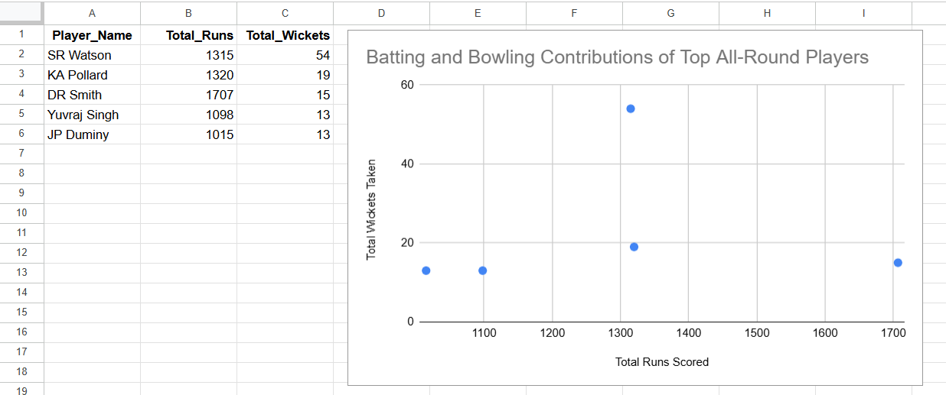
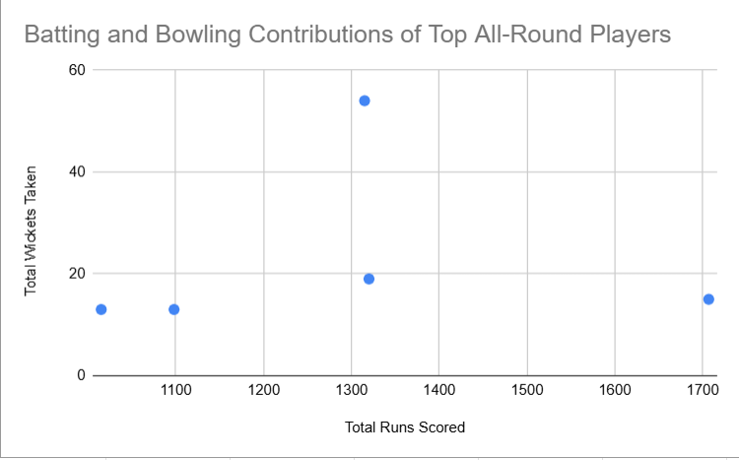

Approach
To identify versatile players who can contribute effectively with both bat and ball, a SQL query was executed to find players who had scored more than 1000 runs and taken more than 10 wickets. These criteria helped identify genuine all-rounders who consistently contribute in multiple aspects of the game. The results were then visualized using a Scatter Plot, where batting contribution (runs) and bowling contribution (wickets) were plotted simultaneously.

Visualization Used
Scatter Plot – Batting and Bowling Contributions of Top All-Round Players
- X-Axis: Total Runs Scored
- Y-Axis: Total Wickets Taken
- Each point represents an all-round player.
The scatter plot allows easy comparison of batting and bowling contributions and helps identify players who excel in both dimensions.

Findings
- Shane Watson emerged as the strongest all-round performer, scoring 1315 runs and taking 54 wickets. His point appears significantly higher than the others on the wickets axis, highlighting his exceptional bowling contribution while maintaining strong batting performance.
- Dwayne Smith recorded the highest batting contribution among the identified all-rounders with 1707 runs, while also taking 15 wickets, making him a valuable batting all-rounder.
- Kieron Pollard demonstrated a balanced contribution with 1320 runs and 19 wickets, providing strength in both departments.
- Yuvraj Singh and JP Duminy also showed versatility by scoring over 1000 runs while taking 13 wickets each, making them useful multi-dimensional players.

Conclusion
The analysis indicates that Shane Watson, Kieron Pollard, Dwayne Smith, Yuvraj Singh, and JP Duminy are the most versatile players in the dataset. Among them, Shane Watson stands out as the most impactful all-rounder due to his combination of substantial run-scoring ability and outstanding wicket-taking performance. The scatter plot effectively highlights these players as valuable team assets capable of contributing with both bat and ball, thereby improving overall team balance and flexibility.

Q5 Are there players whose presence positively influences the morale and performance of the team? (justify your answer using visualization)
WITH MOTM AS (
SELECT
Man_of_the_Match AS Player_Id,
COUNT(*) AS Man_Of_The_Match_Awards
FROM matches
GROUP BY Man_of_the_Match
),
RUNS AS (
SELECT
Striker AS Player_Id,
SUM(Runs_Scored) AS Total_Runs
FROM ball_by_ball
GROUP BY Striker
)
SELECT
p.Player_Name,
m.Man_Of_The_Match_Awards,
COALESCE(r.Total_Runs,0) AS Total_Runs
FROM MOTM m
JOIN player p
ON m.Player_Id = p.Player_Id
LEFT JOIN RUNS r
ON p.Player_Id = r.Player_Id
ORDER BY m.Man_Of_The_Match_Awards DESC, Total_Runs DESC
LIMIT 10;
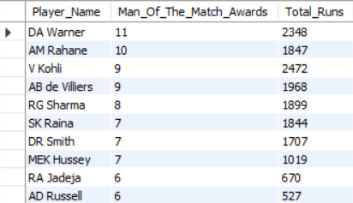
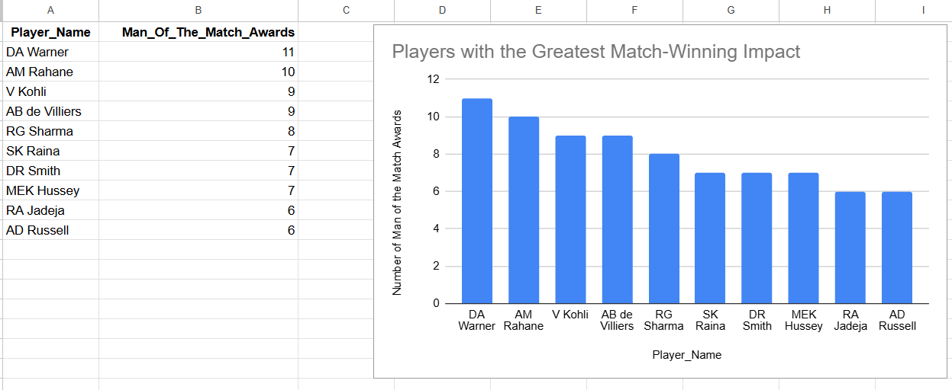
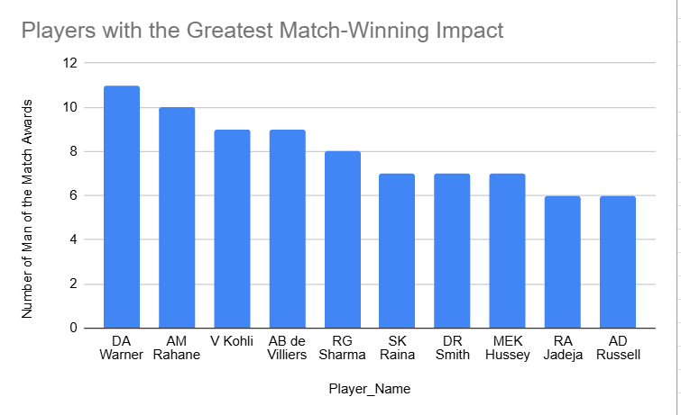

Approach
Player morale cannot be measured directly from the available IPL dataset. Therefore, Man of the Match (MOTM) awards were used as a proxy measure to identify players who consistently delivered match-winning performances and positively influenced team success. Players receiving a high number of MOTM awards are likely to have made significant contributions in crucial situations, thereby boosting both team performance and confidence.

Visualization Used
Column Chart – Players with the Greatest Match-Winning Impact
- X-Axis: Player Name
- Y-Axis: Number of Man of the Match Awards
The visualization compares the frequency with which players received Man of the Match awards, highlighting those who most frequently influenced match outcomes.
Findings
- David Warner received the highest number of Man of the Match awards (11), indicating his consistent ability to deliver match-winning performances.
- Ajinkya Rahane followed closely with 10 awards, demonstrating his significant impact on team success.
- Virat Kohli and AB de Villiers each secured 9 awards, reflecting their ability to perform under pressure and contribute in crucial situations.
- Rohit Sharma, Suresh Raina, and Dwayne Smith also recorded multiple Man of the Match awards, suggesting a strong positive influence on their respective teams.
- The chart clearly shows that these players repeatedly emerged as key contributors in winning matches, making them valuable assets both on and off the field.

Q6 What would you suggest to RCB before going to the mega auction?
WITH Batting AS (
SELECT
Striker AS Player_Id,
SUM(Runs_Scored) AS Total_Runs
FROM ball_by_ball
GROUP BY Striker
),
Bowling AS (
SELECT
b.Bowler AS Player_Id,
COUNT(w.Player_Out) AS Total_Wickets
FROM ball_by_ball b
JOIN wicket_taken w
ON b.Match_Id = w.Match_Id
AND b.Innings_No = w.Innings_No
AND b.Over_Id = w.Over_Id
AND b.Ball_Id = w.Ball_Id
GROUP BY b.Bowler
)
SELECT
p.Player_Name,
COALESCE(bt.Total_Runs,0) AS Total_Runs,
COALESCE(bw.Total_Wickets,0) AS Total_Wickets,
(COALESCE(bt.Total_Runs,0) + (COALESCE(bw.Total_Wickets,0) * 20)) AS Player_Score
FROM player p
LEFT JOIN Batting bt
ON p.Player_Id = bt.Player_Id
LEFT JOIN Bowling bw
ON p.Player_Id = bw.Player_Id
ORDER BY Player_Score DESC
LIMIT 15;
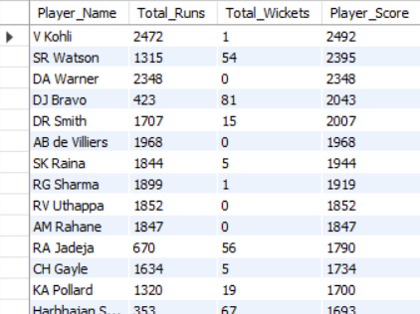

Approach
A player ranking model was created using batting and bowling contributions. Each player's total runs and total wickets were combined into a Player Score, allowing the identification of players who provide the greatest overall value to a team.

Findings
The analysis highlights several player profiles:

Elite Batsmen
- Virat Kohli (Player Score: 2492)
- David Warner (Player Score: 2348)
- AB de Villiers (Player Score: 1968)
- Rohit Sharma (Player Score: 1919)
These players contribute heavily through run scoring and provide stability to the batting lineup.

High-Impact All-Rounders
- Shane Watson (Player Score: 2395)
- Dwayne Smith (Player Score: 2007)
These players contribute significantly with both bat and ball, improving overall team balance.

Specialist Bowlers
- DJ Bravo (Player Score: 2043)
- Harbhajan Singh (Player Score: 1693)
- JP Faulkner (Player Score: 1679)
These players provide strong wicket-taking ability and can strengthen the bowling attack.
Recommendations for RCB
Based on the analysis, RCB should focus on the following areas before the mega auction:
- Acquire quality all-rounders such as Shane Watson-type players who can contribute in multiple departments.
- Strengthen the bowling unit by targeting proven wicket-takers similar to DJ Bravo and JP Faulkner.
- Reduce dependence on a few star batsmen by building a stronger middle order.
- Prioritize players with high overall player scores, as they provide greater value and flexibility.
- Maintain a balance between batting depth and bowling strength rather than investing heavily in batting alone.

Conclusion
The player ranking analysis suggests that RCB would benefit most from targeting versatile all-rounders and wicket-taking bowlers while maintaining a strong batting core. Players such as Shane Watson, DJ Bravo, Dwayne Smith, and JP Faulkner demonstrate the type of balanced contributions that can help RCB build a more competitive and well-rounded squad for future seasons.
Q7 What do you think could be the factors contributing to the high-scoring matches and the impact on viewership and team strategies
SELECT
v.Venue_Name,
ROUND(AVG(bbb.Runs_Scored), 2) AS Avg_Runs_Per_Ball,
ROUND(SUM(bbb.Runs_Scored) * 1.0 / COUNT(DISTINCT m.Match_Id), 2) AS Avg_Total_Per_Match
FROM ball_by_ball bbb
JOIN matches m
ON bbb.Match_Id = m.Match_Id
JOIN venue v
ON m.Venue_Id = v.Venue_Id
GROUP BY v.Venue_Name
ORDER BY Avg_Total_Per_Match DESC;
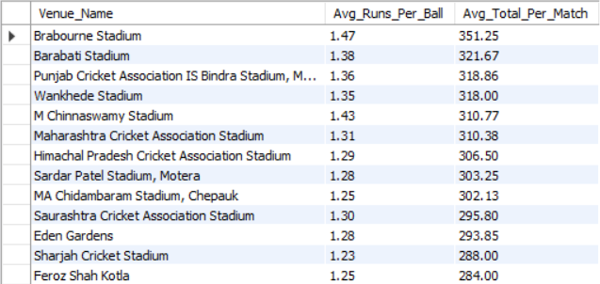

Approach
To identify the factors contributing to high-scoring matches, a venue-wise analysis was performed using average runs scored per ball and average total runs scored per match. These metrics help determine which venues provide favorable conditions for batting and consistently produce high-scoring contests.

Factors Contributing to High-Scoring Matches
The results suggest that several factors contribute to high-scoring IPL matches:
- Batting-Friendly Pitch Conditions
Venues such as Brabourne Stadium and M Chinnaswamy Stadium exhibit high average runs per ball, indicating pitches that favor batsmen and allow free stroke play.
- Short Boundaries and Fast Outfields
Smaller boundaries and quicker outfields increase the likelihood of boundaries, leading to higher run totals.
- Aggressive Batting Approach
Teams often adopt attacking strategies at high-scoring venues, especially during the powerplay and death overs, which further accelerates scoring.
- Challenges for Bowlers
Favorable batting conditions reduce the effectiveness of bowlers, making it more difficult to contain runs and defend moderate totals.
Impact on Viewership
High-scoring matches generally have a positive impact on viewership because they:
- Produce more fours and sixes.
- Create exciting run chases and close finishes.
- Increase entertainment value for spectators.
- Generate greater fan engagement and media attention.
As a result, high-scoring games tend to attract larger audiences and maintain viewer interest throughout the match.
Impact on Team Strategies
The presence of high-scoring venues influences team strategies in several ways:
- Teams prioritize aggressive batsmen with high strike rates.
- Greater importance is placed on power hitters and finishers.
- Teams seek bowlers who can perform effectively under high-scoring conditions, particularly in the death overs.
- Captains often adopt attacking tactics to take wickets rather than focusing solely on run containment.
Conclusion
The analysis indicates that venues such as Brabourne Stadium, Barabati Stadium, Wankhede Stadium, and M Chinnaswamy Stadium consistently produce high-scoring matches due to favorable batting conditions and higher scoring rates. These matches enhance spectator engagement and influence team selection and tactical decisions, encouraging teams to focus on aggressive batting lineups, power hitters, and specialist bowlers capable of performing in batting-friendly environments.

Q8 Analyze the impact of home-ground advantage on team performance and identify strategies to maximize this advantage for RCB.
SELECT
CASE
WHEN v.Venue_Name = 'M Chinnaswamy Stadium'
THEN 'Home Ground'
ELSE 'Away Ground'
END AS Venue_Type,
COUNT(*) AS Matches_Played,
SUM(
CASE
WHEN m.Match_Winner = (
SELECT Team_Id
FROM team
WHERE Team_Name = 'Royal Challengers Bangalore'
)
THEN 1
ELSE 0
END
) AS Matches_Won,
ROUND(
SUM(
CASE
WHEN m.Match_Winner = (
SELECT Team_Id
FROM team
WHERE Team_Name = 'Royal Challengers Bangalore'
)
THEN 1
ELSE 0
END
) * 100.0 / COUNT(*),
2
) AS Win_Percentage
FROM matches m
JOIN venue v
ON m.Venue_Id = v.Venue_Id
WHERE (
m.Team_1 = (
SELECT Team_Id
FROM team
WHERE Team_Name = 'Royal Challengers Bangalore'
)
OR
m.Team_2 = (
SELECT Team_Id
FROM team
WHERE Team_Name = 'Royal Challengers Bangalore'
)
)
GROUP BY Venue_Type;

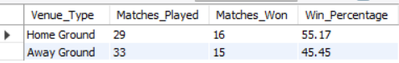
Approach
To evaluate the impact of home-ground advantage, RCB's performance at its home venue, M Chinnaswamy Stadium, was compared against its performance at all other venues. The analysis measured matches played, matches won, and overall win percentage for home and away games.

Findings
The analysis shows that RCB performs noticeably better at its home ground than at away venues.
- At M Chinnaswamy Stadium, RCB won 16 out of 29 matches, achieving a win percentage of 55.17%.
- At away venues, RCB won 15 out of 33 matches, resulting in a lower win percentage of 45.45%.
- The difference of nearly 10 percentage points indicates that RCB benefits from a clear home-ground advantage.
This suggests that familiarity with pitch conditions, crowd support, and knowledge of local playing conditions positively influence team performance.
Strategies to Maximize Home-Ground Advantage

1. Build a Batting-Oriented Squad
M Chinnaswamy Stadium is known for producing high-scoring matches due to its batting-friendly conditions and relatively short boundaries. RCB should continue investing in aggressive batsmen and power hitters who can exploit these conditions.

2. Recruit Effective Death Bowlers
Since high scores are common at the venue, RCB should prioritize bowlers who can execute yorkers, slower deliveries, and variations during the death overs to control opposition scoring.

3. Select Players Suited to Local Conditions
Players with strong records at M Chinnaswamy Stadium should be prioritized during team selection, as familiarity with local conditions can improve performance.

4. Utilize Aggressive Home Strategies
Given the favorable batting conditions, RCB can adopt more attacking strategies at home, particularly during the powerplay and death overs.

5. Leverage Crowd Support
Home crowd support can boost player confidence and create additional pressure on visiting teams. Maintaining a strong home record can therefore provide both psychological and competitive advantages.
Conclusion
The analysis confirms that RCB benefits from a significant home-ground advantage, achieving a 55.17% win rate at M Chinnaswamy Stadium compared to 45.45% at away venues. To maximize this advantage, RCB should focus on recruiting players suited to batting-friendly conditions, strengthen its death-over bowling resources, and continue adopting aggressive strategies that capitalize on the characteristics of its home ground.

Q9 Come up with a visual and analytical analysis of the RCB's past season's performance and potential reasons for them not winning a trophy.

Approach
To evaluate RCB's historical performance, multiple key performance indicators were analyzed, including team scoring ability, boundary contribution, and home-ground advantage. The findings were supported using visualizations to understand both the strengths of the team and the factors that may have prevented them from winning an IPL title.

1. Batting Performance Analysis
The Average Team Score Comparison chart shows that RCB recorded the highest average team score (153.24) among all teams in the dataset.
Observation:
- RCB consistently posted competitive totals.
- The team possessed one of the strongest batting lineups in the league.
- Players such as Virat Kohli and AB de Villiers played a major role in driving the team's batting success.
Inference:
RCB's inability to win a trophy cannot be attributed to weak batting performance, as they outperformed most teams in terms of average runs scored.

2. Aggressive Batting Strategy
The Boundary Contribution Percentage chart revealed that 63.47% of RCB's runs came through boundaries, the highest among all teams analyzed.
Observation:
- RCB relied heavily on fours and sixes to build large totals.
- The team adopted an aggressive batting approach throughout the innings.
- Their batting style was highly effective on batting-friendly surfaces.
Inference:
While aggressive batting helped RCB score heavily, excessive reliance on boundary scoring may have made the team vulnerable when key batsmen failed or when conditions favored bowlers.
3. Home vs Away Performance
Observation:
- RCB performed significantly better at M Chinnaswamy Stadium than at away venues.
- The team benefited from familiarity with local conditions and strong crowd support.
Inference:
The drop in performance away from home indicates inconsistency across different venues and playing conditions

Potential Reasons for Not Winning a Trophy

1. Overdependence on Batting Strength
Although RCB possessed one of the strongest batting lineups, success in T20 cricket requires a balance between batting and bowling. The team's results suggest that batting strength alone was insufficient to consistently secure championships.

2. Inconsistent Away Performances
The difference between home and away win percentages indicates that RCB struggled to replicate its home success at other venues. Championship-winning teams generally maintain strong performances regardless of venue.

3. Lack of Balance in Team Composition
The analysis indicates that RCB's strategy focused heavily on run scoring and aggressive batting. Teams that consistently win tournaments often combine:
- Strong batting depth,
- Reliable wicket-taking bowlers,
- Effective death-over specialists,
- Quality all-rounders.

4. Dependence on Key Players
RCB's success was often driven by a few star performers. When these players underperformed, the team found it difficult to maintain the same level of competitiveness.
Conclusion
The analysis shows that RCB was one of the strongest batting teams in the IPL, leading several key batting metrics including average team score and boundary contribution percentage. However, their lower away win percentage and apparent overreliance on batting suggest a lack of overall team balance. To improve their chances of winning future trophies, RCB should focus on strengthening their bowling attack, investing in quality all-rounders, and building a squad capable of performing consistently across different venues and match conditions.

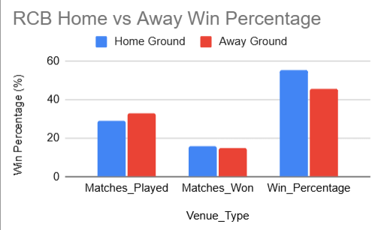

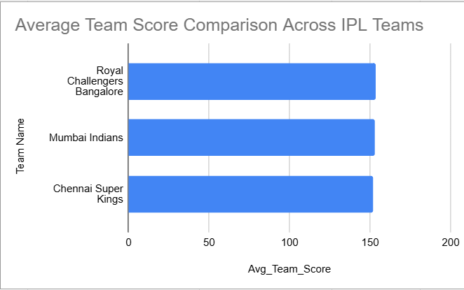
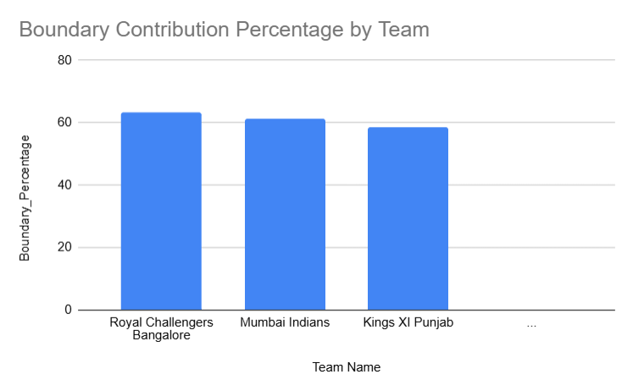

Q10 How would you approach this problem, if the objective and subjective questions weren't given?
Without a predefined list of questions, the approach would be more exploratory, following a structured data-analysis process:
- Understand the data first: study the schema (Player, Matches, Ball_by_Ball, Wicket_Taken, etc.), check what each table/column represents, and identify how tables connect (Match_Id, Player_Id, Team_Id).
- Define the objective: since the brief is about RCB, the natural goal is “what helps RCB win, and where are they weak?” — a clear north star for all further analysis.
- Run descriptive statistics first: matches played/won per season, top run-scorers, top wicket-takers, win % by venue, toss decision, batting/bowling phase — to get a feel for the data before asking specific questions.
- Segment the data: by season, by match phase (powerplay/middle/death), by venue (home/away), by opponent, and by whether key players played — segmentation is usually where the real insight shows up.
- Form hypotheses from what's seen in the segmented data (e.g. “does winning the toss matter?”, “is there a weak bowling phase?”) and test each one with a focused SQL query.
- Visualize each finding (bar/line/scatter charts) so patterns are easy to communicate, not just numbers in a table.
- Translate findings into actionable recommendations — the same structure used for Q2, Q3 and Q6 above, just arrived at by exploration instead of being told what to look for.

Q11 In the "Match" table, some entries in the "Opponent_Team" column are incorrectly spelled as "Delhi_Capitals" instead of "Delhi_Daredevils". Write an SQL query to replace all occurrences of "Delhi_Capitals" with "Delhi_Daredevils".
Desc match;
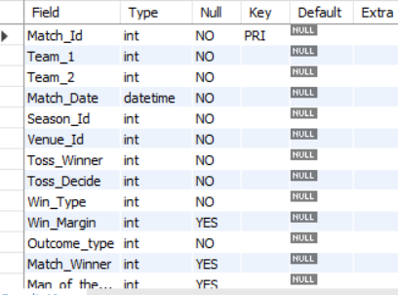
Since the database schema does not contain an Opponent_Team column and the team name already exists correctly as Delhi Daredevils in the team table, the requested update could not be applied and no data correction was necessary.
SELECT Team_Id, Team_Name
FROM team
WHERE Team_Name LIKE '%Delhi%';
